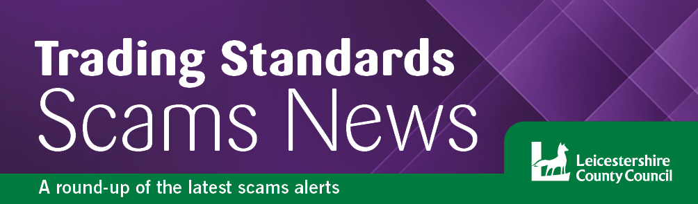
Winter 2024
Welcome….
to the latest edition of the Leicestershire Trading Standards Service scams newsletter. Here you will find details of the latest scams and information about how to protect yourself and report a scam.

Protect yourself from scams in 2024
With fraud losses in 2023 expected to exceed £1bn, there are steps you can take to protect yourself from falling victim to a fraud or scam, including staying aware of how scams tend to work and how to protect your personal information.

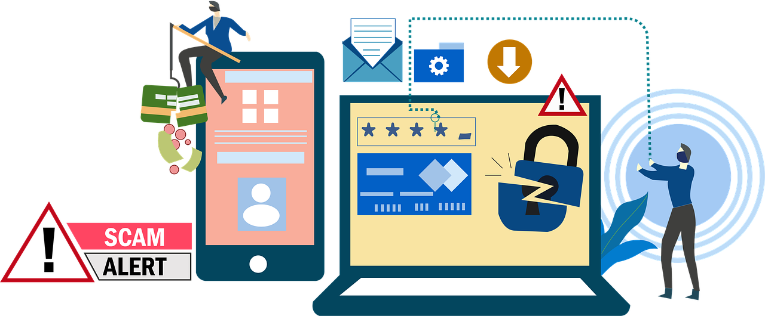

If you receive a request to provide personal or financial information, the advice is to take a step back from the situation, taking a moment to reflect and think about what really could be going on. Many of us may already know the basic rules on how to beat financial fraud, but just remember to take a breath and think of the following guidelines, to avoid getting caught out.
- Don’t assume an email or phone call is authentic
Just because someone knows your basic details such as your name and address, it doesn’t mean they are genuine. Be mindful of who you trust, as criminals may try to trick you by telling you that you’ve been a victim of fraud. They will use this to draw you into the conversation and scare you into acting and revealing security details. Remember, criminals can also make any telephone number appear on your phone handset so even if you recognise it or it seems authentic, do not use it as verification they are genuine.

- Requests to move money
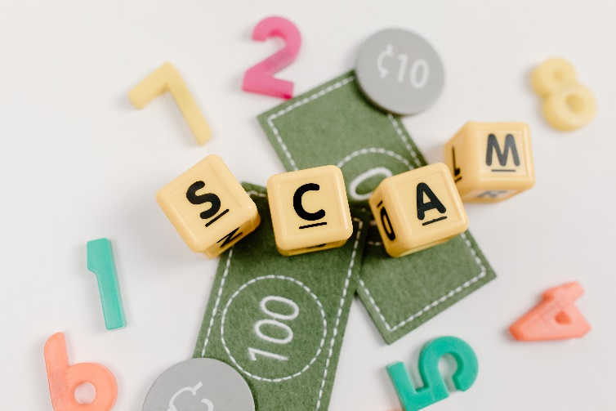
A genuine bank or organisation will never contact you out of the blue to ask for your PIN, password or to move money to another account.
Nor would they ask you to hand them cash or cards for safe keeping, or collection from your home.

- Clicking on links or files
Don’t be tricked into giving a fraudster access to your personal or financial details. Never automatically click on a link in an unexpected email or text.
- Don’t be rushed or pressured into making a decision
Under no circumstances would a genuine bank or other trusted organisation push you to make a financial transaction on the spot, nor would they ask you to transfer money into another account for fraud reasons.
Remember to stop and take time to carefully consider your actions. A legitimate organisation won’t rush you or mind waiting if you want time to think.
- Listen to your instincts
If something feels wrong, then it is usually right to question it. Scammers can pull you into a false sense of security when you are out and about or rely on your defences being down when you’re in the comfort of your own home. They may appear trustworthy, but they may not be who they claim to be.
- Stay in control
Have the confidence to refuse unusual requests for personal or financial information. It’s easy to feel embarrassed when faced with unexpected or complex conversations. But it’s okay to stop the discussion if you do not feel in control of it.
If you’ve taken all these steps and still feel uncomfortable or unsure about what you’re being asked, never hesitate to contact your bank or financial service provider on a number you trust, such as the one listed on their website or on the back of your payment card. Or, ask a trusted person such as family, friend, neighbour or carer.
For advice about how to report various scams, please see the advice at the end of this newsletter.

Leicestershire Police Courier Fraud Warning
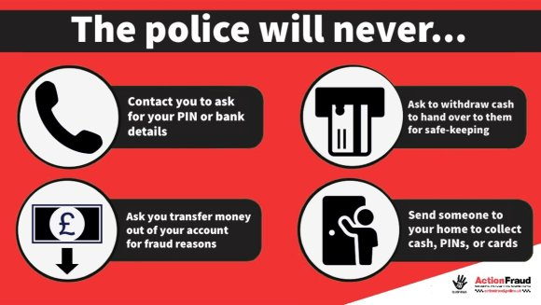
Leicestershire police are raising awareness regarding recent reports of courier fraud, as Leicestershire residents have fallen victim to these types of scams.
Criminals will target anyone, but recent victims are often elderly, and thousands of pounds have been lost.

The images and links provide vital information, and you can visit useful websites such as Action Fraud, Age UK and Crimestoppers to help you spot the signs of courier fraud.

Raising awareness can prevent a friend, relative or neighbour from losing thousands of pounds, particularly if they just hang up the phone.

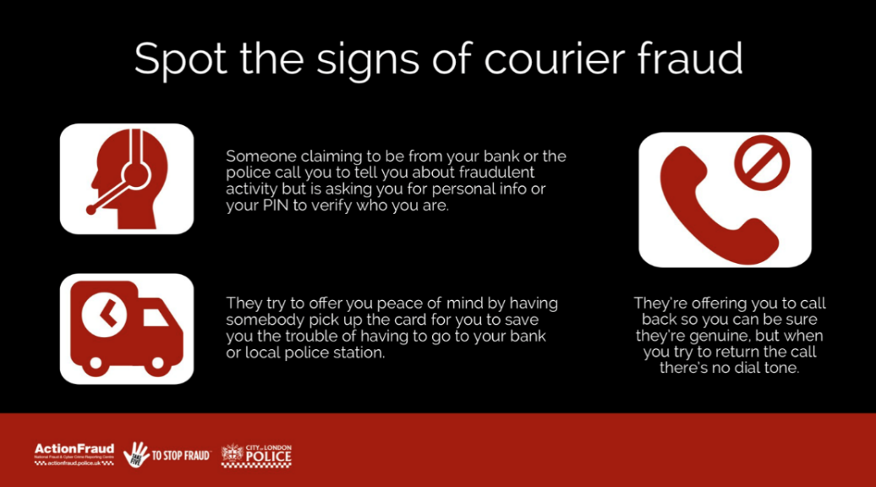
Remember that people of all ages can be targeted and have fallen victim to these types of crime. The impact this can have on people is devastating. If you have fallen victim to this, immediately call your bank’s direct line. It is really important to NEVER give your bank details out over the phone.
Crimestoppers
https://crimestoppers-uk.org

Action Fraud
https://www.actionfraud.police.uk/reporting-fraud-and-cyber-crime

Age UK
https://www.ageuk.org.uk/scams

Romance scams
If you are looking for friendship and even romance, be aware that fraudsters will be spend time researching and looking for targets by using information found on social media.
Be aware:
- They will create fake identities to target you.
- They will take time to build a relationship and gain your trust.
- They will eventually ask you for money.

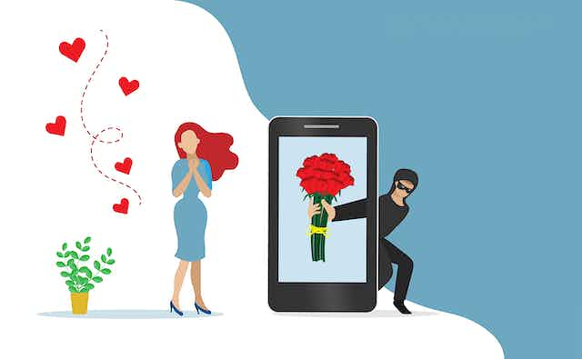
No matter how long you’ve been speaking to someone online and how much you trust them, if you have not met them in person, it’s important that you do not:
- Send them any money or give them your bank details
- Allow them access to your bank account
- Transfer money on their behalf
- Take a loan out for them
- Provide copies of your personal documents such as passport or driving licence
- Invest your own money on their behalf or on their advice
- Purchase and send the codes on gift cards from
Amazon, iTunes or Google Play
- Agree to receive or send parcels on their behalf (laptops, mobile phones etc.)

Things to consider when using dating apps or websites:
- How do they look on their profile picture? Professional photos with supermodel looks could be a red flag, as profile photos may not be genuine; do your research first. Performing a reverse image search on a search engine can find photos that have been taken from somewhere or someone else.
- Avoid giving away too many personal details online. Revealing your full name, date of birth and home address may lead to your identity being stolen.
- Pick a reputable dating website and use the site’s messaging service. Criminals want to quickly switch to social media or texting so there’s no evidence of them asking for money.
- Be wary of those who want to get too close, too quickly.
- Do you know who they really are – have you met their friends, family, work colleagues?
- Are you being asked for money to help with some emergency - lost passport, relative in danger, even expensive treatment for an illness. All of these have been used to con people out of money.

- If it all sounds too good to be true, question them and ask for facts that you can verify.

You can report suspicious dating or social media websites to https://www.ncsc.gov.uk/report-scam-website, as the criminals behind them might not just be deceiving one person, and your report could help protect others.

If you think you have been a victim of a romance scam, do not feel ashamed or embarrassed - you are not alone. Contact your bank immediately and report it to Action Fraud on 0300 123 2040.

For further information you can go to: https://www.actionfraud.police.uk/dating-fraud

Extreme Weather Rogue Traders Alert
Leicestershire Trading Standards is warning the public to be on guard against rogue traders looking to cash in on residents affected by floods and storm damage. Cold callers may prey on the most vulnerable members of our community that are faced with damaged properties.
We advise the public to:
• Never engage with cold callers knocking on your door or who call out of the blue.
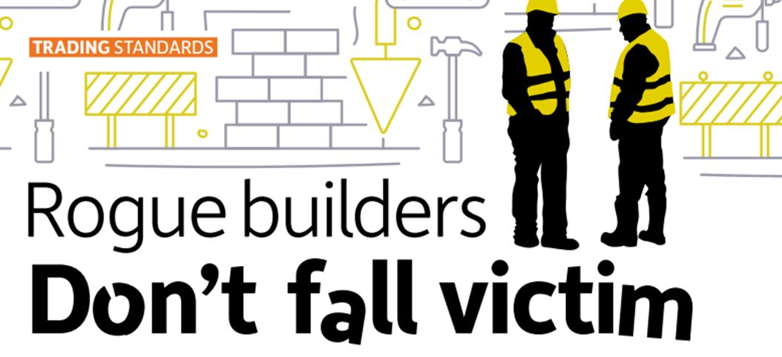
• Get 3 quotes from different and independently sourced traders, and make sure everything agreed is in writing.
• Pay securely rather than by cash, including using a credit card.
• Don’t feel pressured into agreeing work or paying all money up front before work starts – these are red flags.
Get more advice at: Citizensadvice.org.uk/getting-home-improvements

No Cold Calling Door Stickers
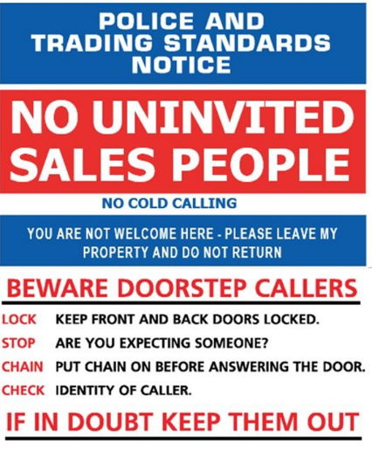
We would like to remind residents that Leicestershire Trading Standards can provide no cold calling door stickers as a deterrent for those who may be experiencing doorstep callers.
The door stickers could be useful for those who may live alone or be particularly vulnerable to cold callers.
If you, a family member, friend or neighbour could benefit from having one of these door stickers, you can request one by calling 0116 305 8000 or email tradingstandards@leics.gov.uk

Finally….

Here's how you can report a wide variety of scams quickly
The National Cyber Security Centre (NCSC) sets out several different ways to report scams depending on the type:
- Email scams. If you get a dodgy looking email, you can report it to the National Cyber Security Centre (NCSC) by forwarding it to report@phishing.gov.uk. Remember not to click on any links within these emails.
- Text scams. If you get a suspicious text message, you can forward it to the number 7726 – this will allow your provider to track the origin of the text and arrange to block or ban the sender if it's a scam. You can also report scam text messages to report@phishing.gov.uk by providing a screenshot of the text message.
- Website scams. If you notice a website that doesn't look quite right, you can easily report the URL to the NCSC directly via its online form - https://www.ncsc.gov.uk/report-scam-website
- Scam adverts. These can currently be reported to the Advertising Standards Authority (ASA) through its online form - https://www.asa.org.uk/report-an-online-scam
If you would like to report a scam, or you have been a victim of a scam, you can get in touch with the following organisations:
Action Fraud – https://www.actionfraud.police.uk/
Citizens Advice Consumer Helpline - 0808 223 1133
To keep up to date with the latest scams information and advice, you can follow the Leicestershire Trading Standards Service Facebook page at: www.facebook.com/leicstradingstandards
Leicestershire Trading Standards Service
Tel: 0116 305 8000
Email: tradingstandards@leics.gov.uk
/LeicsTradingStandards

